Insert Subject | Eid
Insert NCL/KSL
Date:

By the end of these activities: | Most Pupils Will…  Be able to identify patterns used in religious materials
Some Pupils Will…
Be able to identify the traditions shown during Eid
Few Pupils Will…
Be able to identify practices used in the celebration of Eid

Activity | Step by Step | Resources | Cross- curricular Links |  | Sensory Input
 |  |  |  |  |  | Achieved | Revisit | Redo
Activity 1- Hand Henna  To develop my proprioception and visual skills by decorating a hand in henna  I can decorate a hand in Henna | - Cut out hand shapes out of thick card  - In a icing bag, fill ¼ of brown poster paint  - Cut a the end off the bag to create a small hole  - Tie a rubber band around the top to avoid spillages out  - Decorate the hand  OR  - Cut and cook biscuit dough into hand shapes  - Fill the icing bag with melted chocolate  - Decorate the hand biscuits  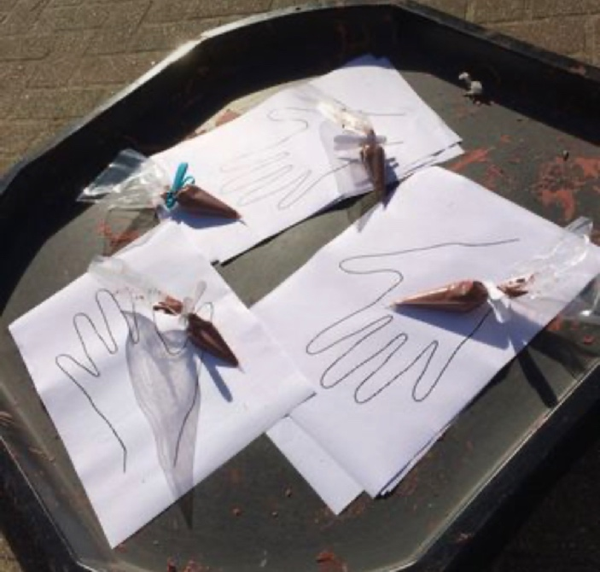 | Hand shape card  Icing bag  Brown paint  Biscuit dough  Hand shape cutter  Melted chocolate | - Maths  - Science  - Art  - RE  - English  - PSHE |  | - Visual  - Proprioception  - Tactile  - Olfactory
Activity 2- Prayer Mat  To develop my visual and tactile skills by creating a prayer mat  I can create a prayer mat | - On a piece of paper, used water colours to paint the background  - Using sequins, gems, feathers, etc, decorate the mat  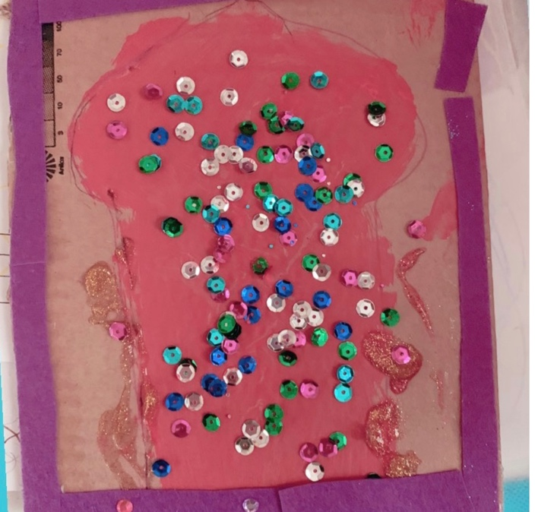 | Paper  Water colour paint  Materials to decorate | - Maths  - Art  - English |  | - Visual  - Proprioception  - Tactile  - Olfactory
Activity 3- Make my own Mosque  To develop olfactory skills by making a gingerbread mosque  I can create a gingerbread mosque | - Heat the oven to 200C/180C fan/gas 6  - Melt the butter, sugar and syrup in a pan. Mix the flour, bicarbonate of soda and ground ginger into a large bowl, then stir in the butter mixture to make a stiff dough. If it won’t quite come together, add a tiny splash of water  - Cut out the shape of a mosque (downloads are available online)  - Put a sheet of baking paper on a work surface and roll about one quarter of the dough to the thickness of two £1 coins  - Place the template onto the dough and cut around  - Bake for 12 mins or until firm and just a little darker at the edges. Leave to cool for a few minutes to firm up  - Using icing and cake decorations decorate once cool  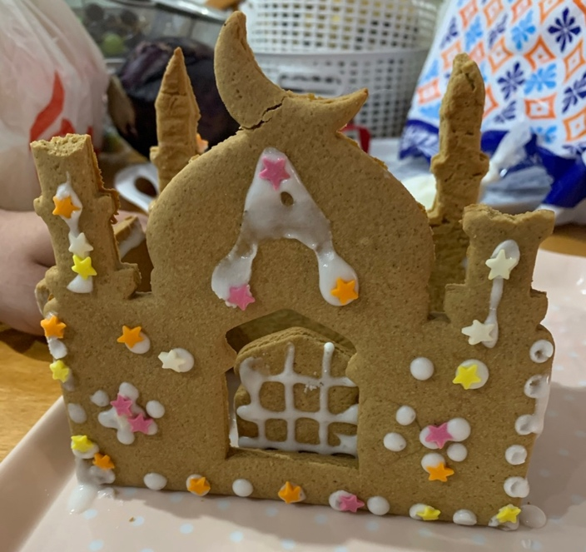 | 250g unsalted butter  200g dark muscovado sugar  7 tbsp golden syrup  600g plain flour  2 tsp bicarbonate of soda  4 tsp ground ginger  Icing sugar  Water  Icing bag |  | - English  - Maths  - Science  - Art  - PSHE | - Visual  - Proprioception  - Vestibular  - Tactile  - Olfactory
Activity 4- Moon Light Catcher  To develop my visual skills by creating a moon light catcher  I can | - Using tinfoil, squeeze and manipulate into a moon crescent  - Create a hole at the top using a hole punch  - Pick fresh flower petals or using gems- decorate the moon  - Hang in the light  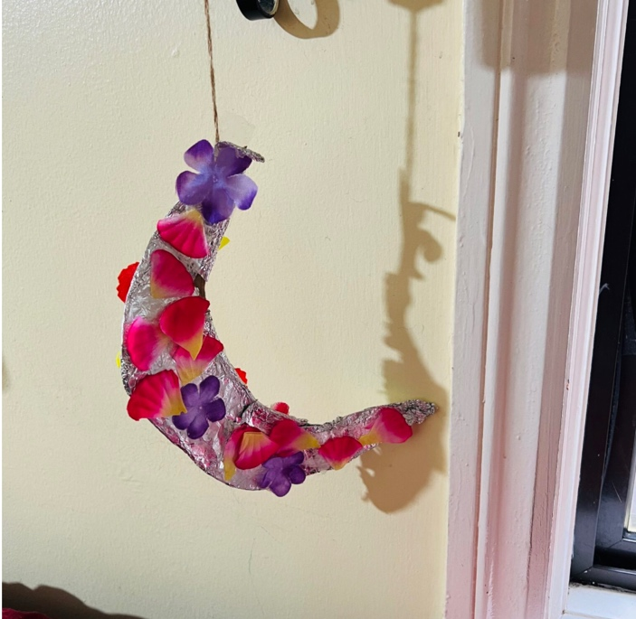 | Tin foil  Flower petals or gems  Ribbon | - Art  - English  - PSHE |  | Visual  - Proprioception
Activity 5- Lantern  I can create a lantern | Using a glass jar remove the lid  PVA glue tissue paper shapes onto the jar  Tie string around the top of the jar and create a loop to hang  Place a none-flame tea-light inside the lantern and watch it shine!  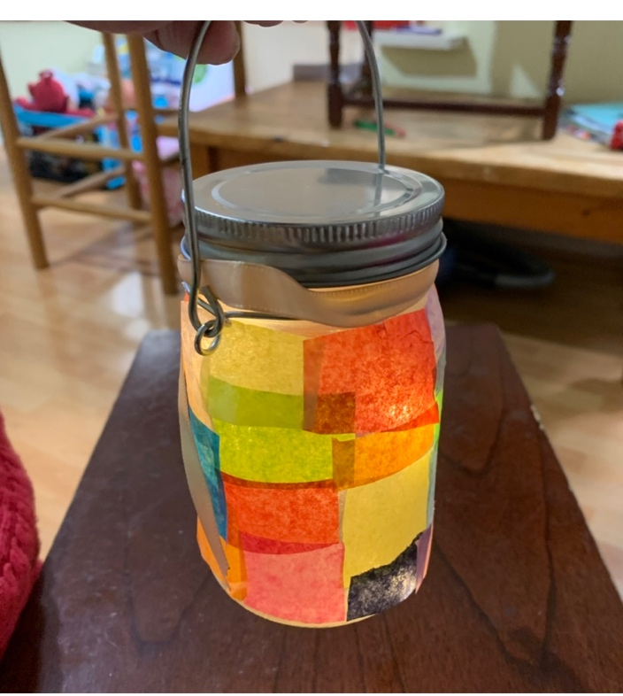 | Glass jar  Tissue paper  PVA glue | - Art  - PSHE |  | - Visual  - Proprioception  - Tactile
Activity 6- Celebration decorations  To develop my proprioception skills by creating celebration decorations  To create a celebration decoration | - Using air dry clay, cut the clay into shapes using a blunt knife or a cookie cutter  - Using a different coloured clay, create small decorations by rolling, cutting, pinching, stamping, pressing into the clay  - Create a small hole at the top with a pencil  - Leave to dry  - Thread some ribbon through and hang  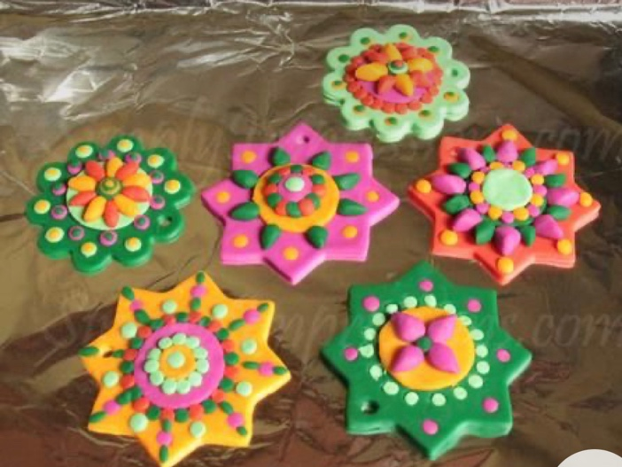 | Air dry clay  Ribbon | - Maths  - Science  - Art  - PSHE |  | - Visual  - Proprioception  - Tactile

