Insert Subject | Summer
Insert NCL/KSL
Date:

By the end of these activities: | Most Pupils Will…  Be able to discover numbers through sensory experiences
Some Pupils Will…
Identify numbers through sensory exploratory experiences
Few Pupils Will…
Complete number challenges using sensory exploratory experiences

Activity | Step by Step | Resources | Cross- curricular Links | Sensory Input
 |  |  |  |  | Achieved | Revisit | Redo
Activity 1- Flower frame  To develop visual, tactile and proprioception skills  I can create flower art | - Cut a piece of cardboard into a picture frame  - Cover one side with sticky tape and sticky back plastic, so that one side is sticky  - Collect flowers and stick them onto the sticky side  - Cover the back with another piece of cardboard or sticky back plastic  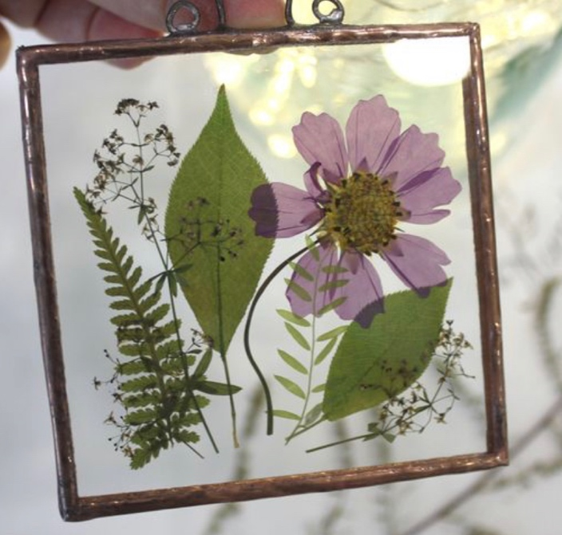 | Cardboard  Tape  Flowers | - Maths  - Science  - Art | - Visual  - Proprioception  - Tactile
Activity 2- Flower Vase  To develop my tactile and proprioception skills  I can create a flower vase | - Make a 5-7cm slice in a tennis ball half way up  - Draw a vase shape onto a bit of cardboard  - Punch holes in the top- spaced out above  - Collect flowers with stems  - Thread the stems through the holes to create flowers  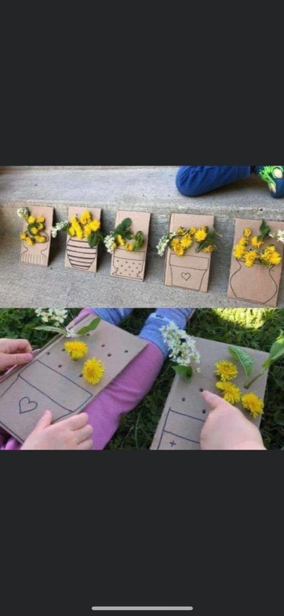 | Tennis ball  Cardboard  Flowers  Hole punch | - Maths  - Art | - Visual  - Proprioception  - Tactile
Activity 3- Plant in a bag  To develop my tactile skills  I can create a growing environment and grow my own plant from a seed | - In a sealable sandwich bag, pour 1/3 full of soil  - Plant a seed  - Tape to a light area  - Water regularly  - Watch the plant grow!  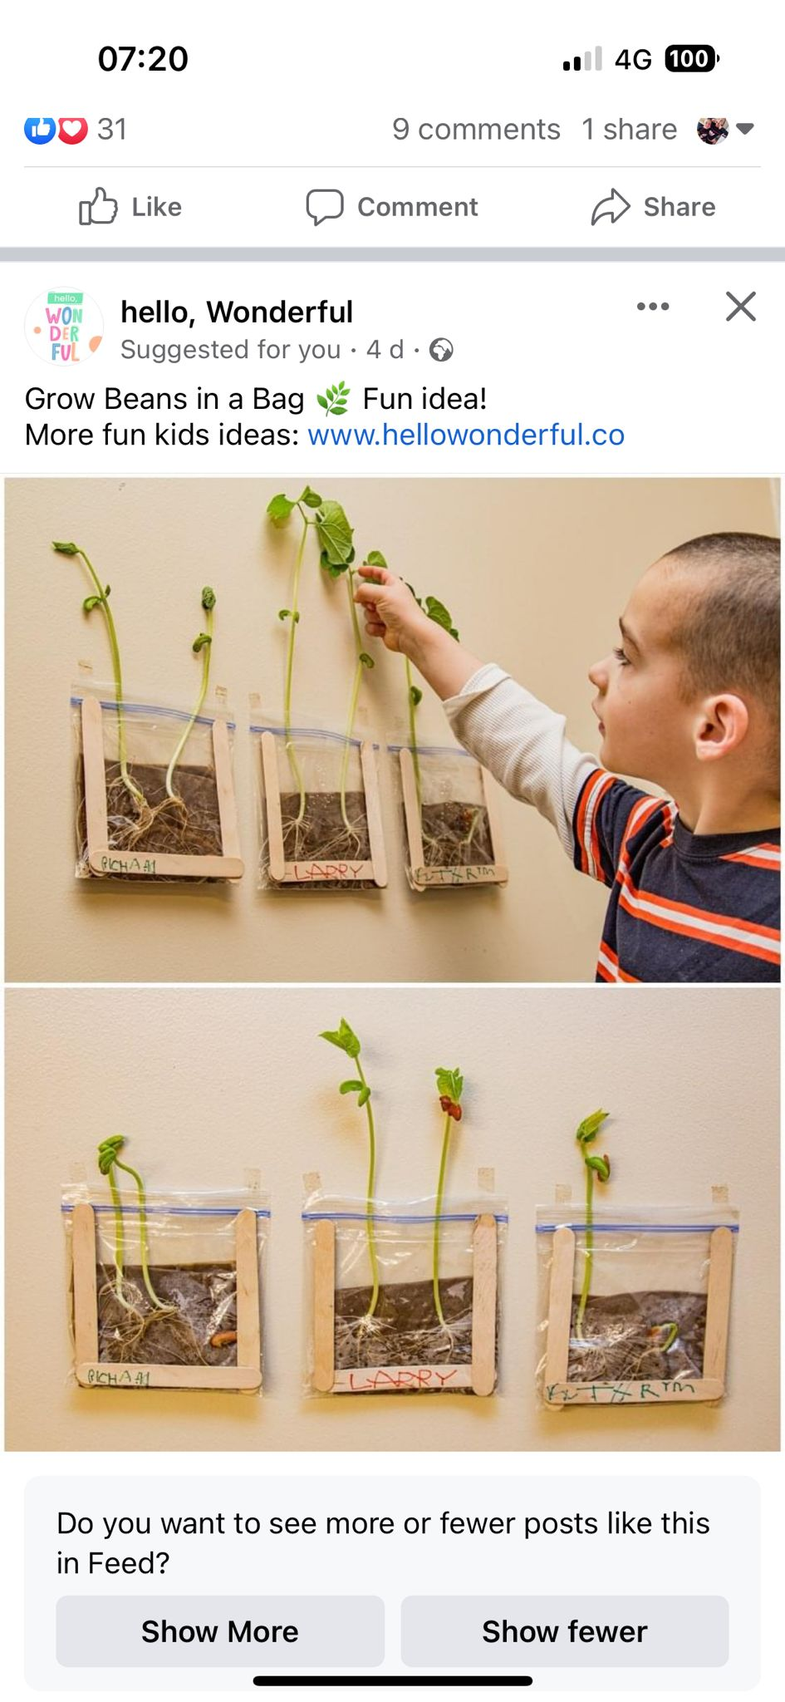 | Sealable sandwich bag  Soil  Seed  water | - English  - Maths  - Science  - Art | - Visual  - Proprioception  - Vestibular  - Tactile  - Olfactory
Activity 4- Flower soup  To develop my olfactory skills  I can create a flower soup | - In a large container, fill ½ with water  - Collect flowers – some with stems some without  - Place the flowers into the water – you may choose to pick some petals off  - Mix with a large plastic spoon  - DO NOT EAT THE SOUP!  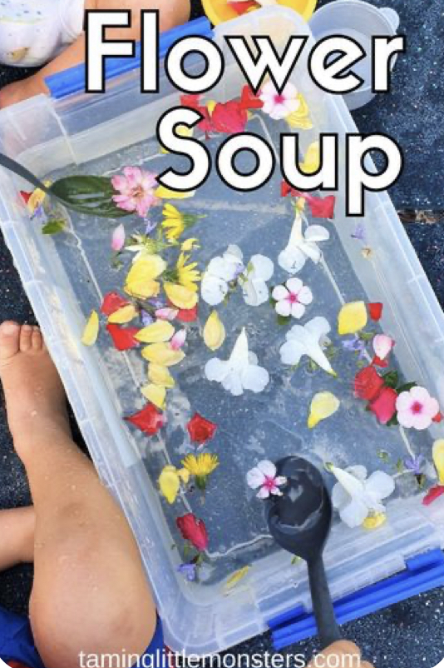 | Container  Water  Flowers | - Maths  - Science | Visual  - Proprioception  - Vestibular  - Tactile  - Taste  - Smell
Activity 5- Plant a flower sieve  To develop my visual, vestibular and proprioception skills  I can create a bunch of flowers by threading through a sieve | - Create flowers using pipe cleaners and tissue paper  - Turn a sieve upside down  - Thread and pull the pipe cleaner side through the holes to create a bunch of flowers  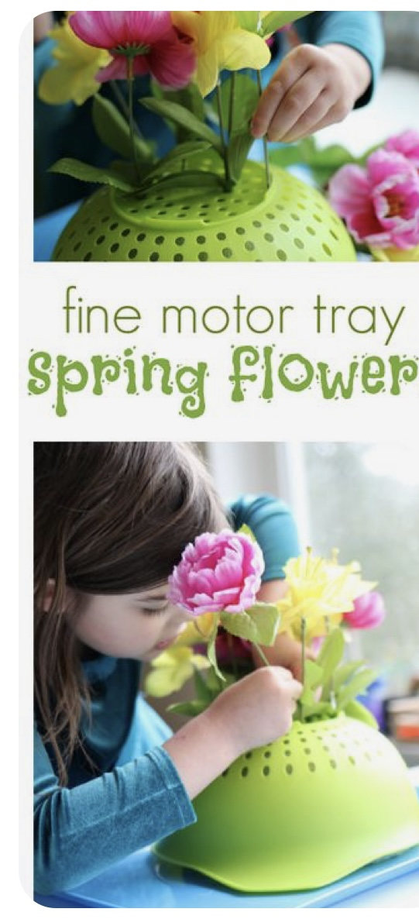 | Sieve  Pipe cleaners  Tissue paper | - Maths  - Art | - Visual  - Proprioception  - Tactile  - Vestibulat
Activity 6- Sensory flower suncatcher | - In a sealable zip bag, fill 1/3 of the way with clear hair gel  - Place flowers and leaves inside the bag  - Seal shut and tape onto a window  - Move the flowers around the gel  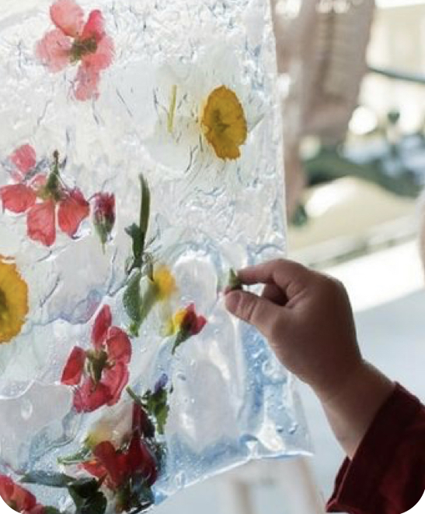 | Sealable bag  Flowers and leaves  Tape | - Maths  - Science  - Art | - Visual  - Proprioception  - Vestibular  - Tactile

